





**Spring 2016 Atlantic Branch Meeting – Registration Form**

**May 25th – May 27th , 2016**

**Crowne Plaza,**

**Fredericton, New Brunswick**

**Hosted By:** **UNB - Limerick Pulp and Paper Centre & PAPTAC Atlantic Branch**

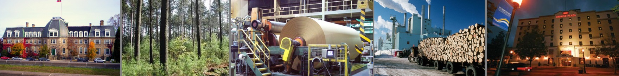

|  |  |  |  |  |  |
| --- | --- | --- | --- | --- | --- |
| **Name:** |  | **Company:** | |  | |
| **Job Title:** |  | **Phone(s):** | |  | |
| **E-Mail:** |  | | | | |
| **Membership**  (select all that apply): | PAPTAC Atlantic Branch Mill Member |  | PAPTAC Atlantic Branch Affiliate Member | |  |
| PAPTAC Honorary Life Member |  | Other | |  |
| Student |  |  | |  |

Note: Registration for Mill Members / Employees, Honorary Life Members and Students is **free**.

Registration fee for Affiliates / Suppliers is **$50**, cash, cheque, or credit card payment to be made at the conference

**Golf Tournament ( Location to be announced)**

* Wednesday, May 25th, 11:00 a.m. – ***must register by May 10 for this event***
* Plan to attend? Yes ___ No ___
* Cost per participant: $69 (Includes rental cost of golf cart per two people)

**Welcoming Social / Reception**

* Wednesday, May 25th, 7:00 p.m. – 10:00 p.m., Crowne Plaza -- Junior Ballroom.
* Hot hors d’oeuvres will be served1
* Plan to attend? Yes___ No ___

**General Meeting & Technical Presentations**

* Thursday, May 26th, 8:00 a.m. – 4:30 p.m., Crowne Plaza -- St John Room
* Registration begins at 7:30 a.m.
* Snacks will be available during registration and stretch breaks1. Note that lunch will not be provided.
* Plan to attend? Yes___ No ___

**Banquet**

* Thursday, May 26th, 6:00 p.m., Crowne Plaza, Junior Ballroom -***must register by May 10 for this event***
* Pre-Banquet Social will begin at 5:00 p.m. in the Junior Ballroom
* Plan to attend? Yes___ No ___

**Tour Pulp and Paper Center**

* Friday, May 27th, 10:30 a.m. – Limerick P&P Center Fredericton, NB-***must register by May 10 for this event***
* Plan to attend? Yes___ No __

1. Please notify us in advance of the conference of any special dietary restrictions.

**Please send completed forms by May 10th to: Carmie Lato – clato@paptac.ca**





**Spring 2016 Atlantic Branch Meeting – Registration Form**

**May 25th – May 27, 2016**

**Crowne Plaza,**

**Fredericton, New Brunswick**

**Hosted By:** **Limerick Pulp and Paper Centre & PAPTAC Atlantic Branch**

*Meeting Attendees are responsible for own hotel bookings

1. **Crowne Plaza (Recommended)**
   * 1-866-444-1946 or (506) 455-3371
   * http://www.cpfredericton.com/

Situated along the banks of the beautiful Saint John River, the Crowne Plaza Fredericton Lord Beaverbrook is just steps from all of Fredericton’s main attractions, shopping, corporate and government offices and nationally recognized universities.

**Crowne Plaza Fredericton Lord Beaverbrook**  
659 Queen Street  
Fredericton, NB  
E3B 5A6

**GPS Coordinates:** N 45 degrees; 96.106 | W 66 degrees; 63.666

**Driving Directions to Hotel**  
**From Fredericton Airport to Crowne Plaza Fredericton Lord Beaverbrook:** Depart on Hwy 102 (West). Keep straight onto Hwy 102 (Lincoln Rd). Bear right (North) onto Hwy 102 (Waterloo Row). Keep straight onto Hwy 102 (Queen St).

Fredericton Airport (YFC)  
Distance: 15 KM / 8 MI

**From other destinations**: consult the map directly on the hotel website -- <http://www.cpfredericton.com/en/location>